Recipe Detail page Design document

## Recipe Detail page

The user doesn’t need to be login to the website to go to Recipe Detail page. On the screen, the user is able to see the whole recipe detail for the recipe which he/she chose on the HomePage or My recipe page. He/she is able to see very important warring - This recipe can contain allergens, please check it before cooking! – to make sure that the user will check carefully the whole ingredients before he/she will eat it. Then the user is able to see the name of the person who create this recipe and the date when the recipe was created. If the user is login to the website and he/she chose his/her recipe, the user is able to see two buttons – UPDATE and DELETE – to update and to delete the recipe. Under this user is able to see – the name of the recipe, photo, Ingredients, Instructions and Nutrients. On the top of the screen is located the navigation bar menu with buttons to dedicated their pages and the logo of the website.

## URL diagram

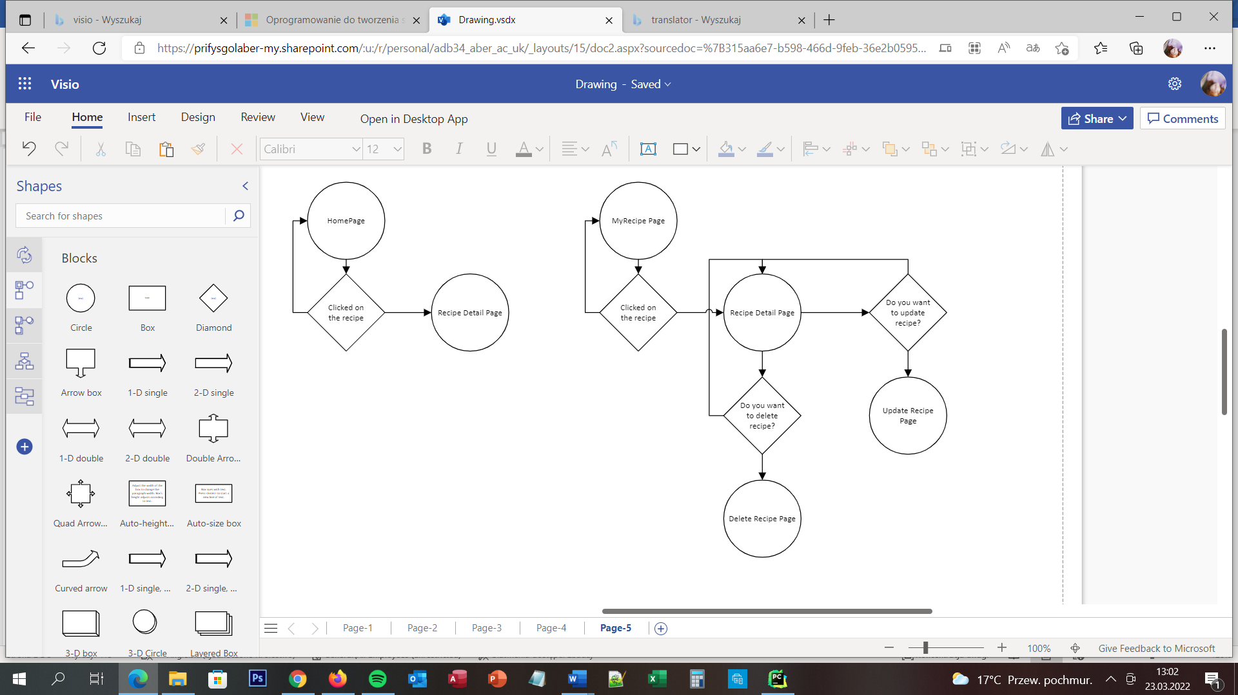

NO

NO

NO

NO

YES

YES

YES

YES

## User Story

The user is able to view all of the details of all of the recipes. He/she is able to do that by going to the HomePage and clicks on the recipe or going to the My Recipe Page and does the same. The user doesn’t need to be login to the website to see the recipe details. The user wants to find the recipe for himself/herself and he/she wants to see all details. The user needs to go to the homepage, find the recipe and clicks on the recipe and then he/she will be moved to Recipe Detail page.

## Acceptance Criteria

The page should display all of the recipe detail, the name of the recipe, picture, ingredients, nutrients and instructions. If the user is login to the website and he/she clicked on his/her recipe server should display two buttons – Update and Delete recipe. Eight buttons should move the user to connecting pages:

* Homepage to Homepage
* About to About Page
* New recipes to Add recipe Page
* My recipes to My Recipes Page
* Profile to the Profile Page
* Logout to Logout Page
* Update to Update Recipe Page
* Delete to Delete Recipe Page

## User interface – Pseudo code

Detail Recipe Page appears for all types of users. On the client-side is chose the recipe. On the server-side it displays all of the recipe details from all of the tables, display buttons Update and Delete when the user is logged in to the website and he/she chose his/her recipe.